
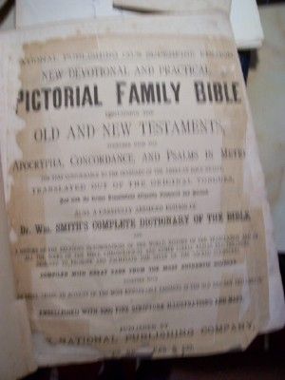
Slatten Family Bible Information:

National Publishing Company
1870
Pictorial Family Bible
Old and New Testaments

Marriages
Tyre Slatten and Julia A. Coy were married March 15, 1858
Annie Slatten was married in 1876
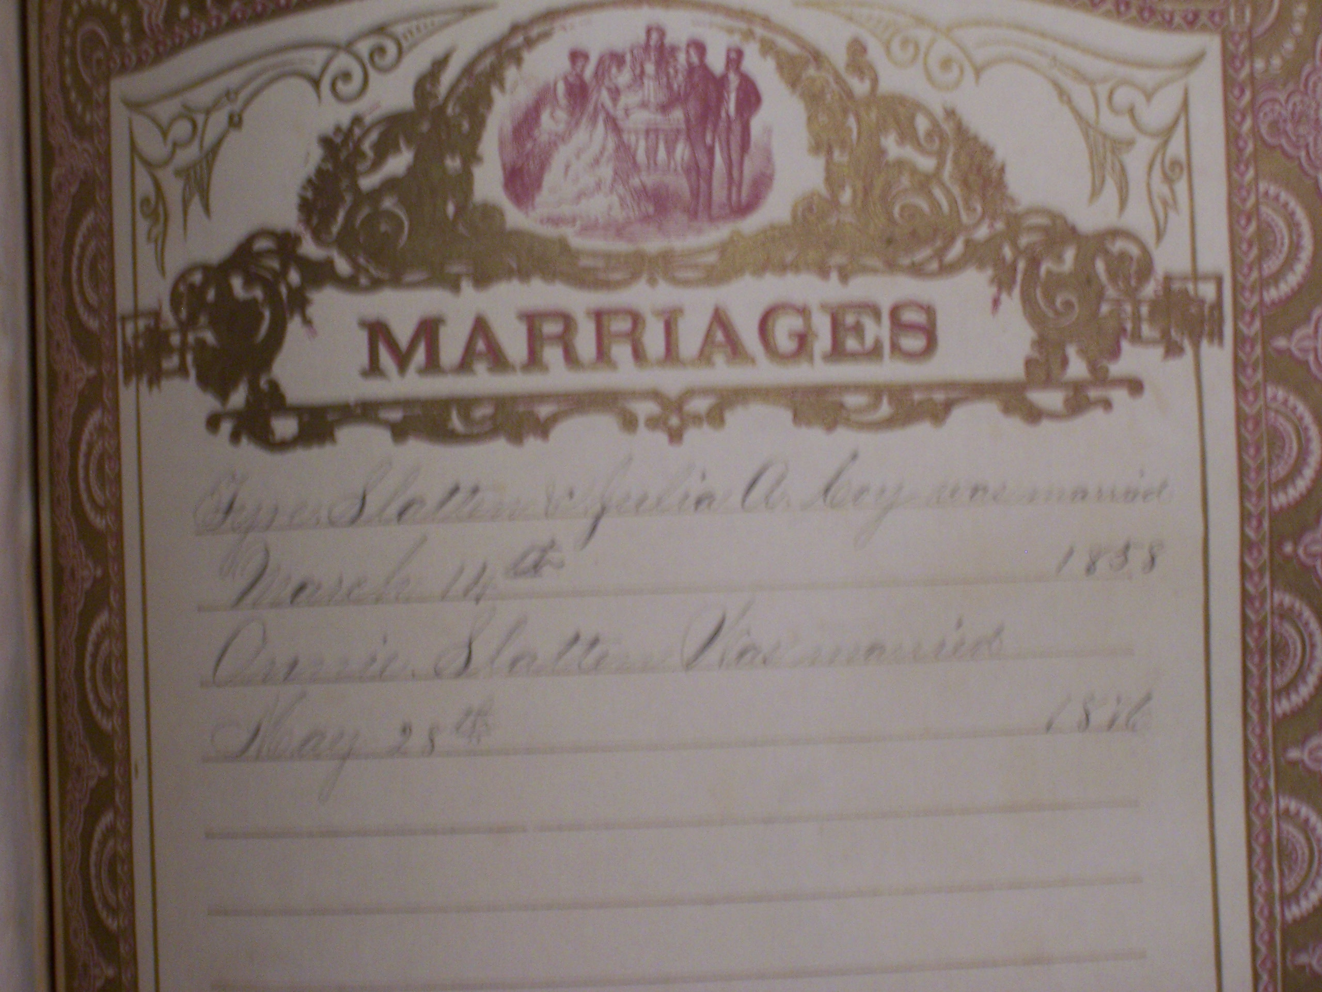

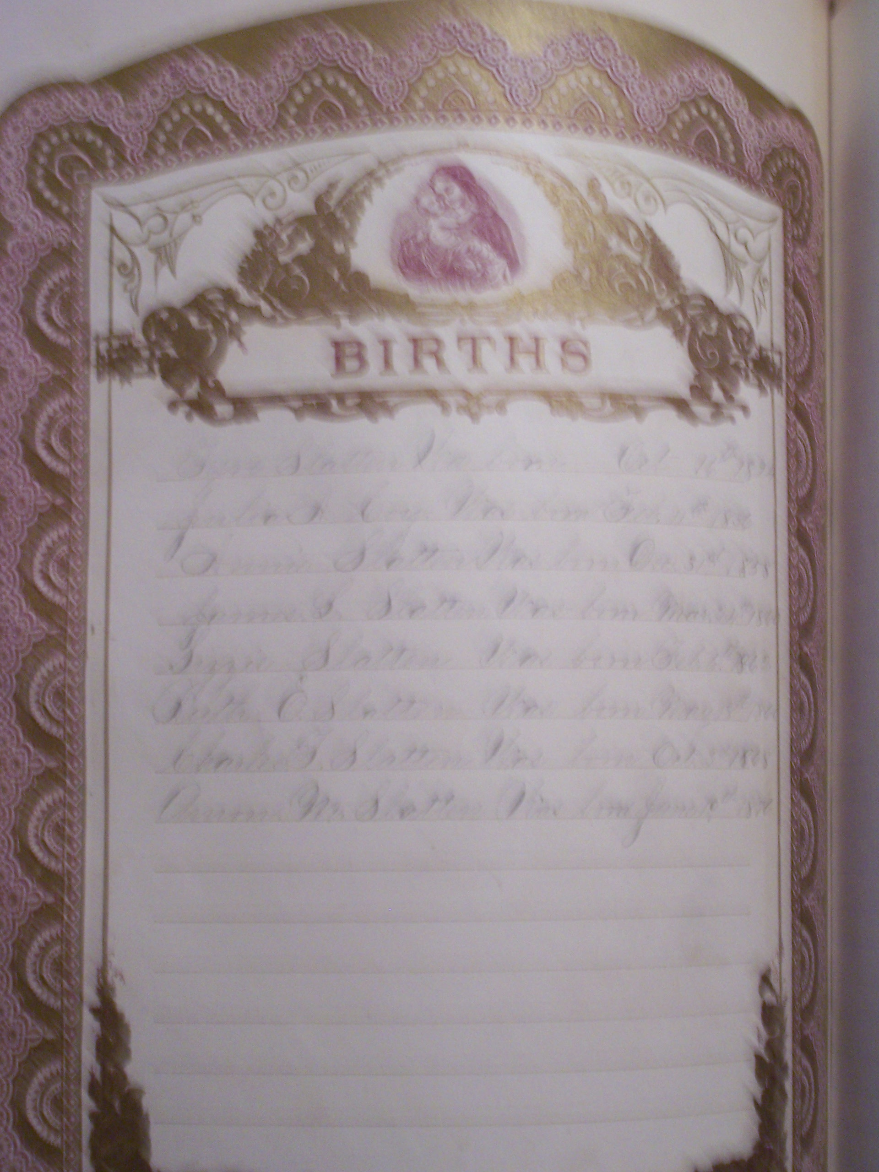

Births

Tyre Slatten was born Oct. 16, 1824
Julia A. Coy was born Feb 11, 1836
Annie Slatten was born Oct. 31 1858
James L. Slatten was born Mar. 24, 1860
Lizzie Slatten was born Feb. 6, 1862
Ruth O. Slatten was born May 18, 1866
Charles T. Slatten was born Oct. 2, 1868
Amon M. Slatten was born Jun. 19, 1876

