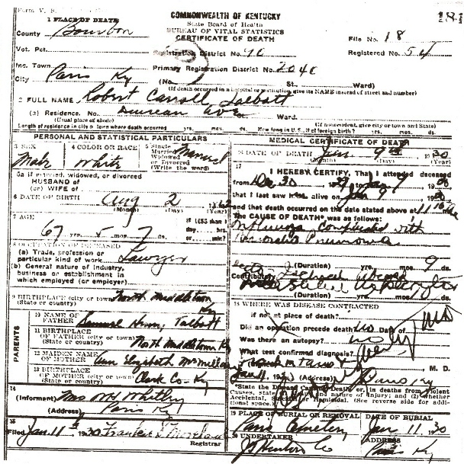
Date: Sun Jan 14 19:35:50 2007
Email: hatton2020@gmail.com
Submitter: Mary Hatton
Death Volume: 1930
Certificate Number: 00184
Surname: TALBOTT Sr.
Given Name: Robert Carroll
Date of Death: 09 Jan 1930
Place of Death: Duncan Ave, Paris, Bourbon Co., Ky.
Race or Color: White
Sex: Male
Marital Status: Married
Spouse's Name:
Spouse's Age:
Cause of Death: Influenza complicated with Brocho Pneumonia
Place of Burial: Paris Cemetery, Paris, Bourbon Co., Ky.
Date of Burial: 11 Jan 1930
Residence: Duncan Ave, Paris, Bourbon Co., Ky.
Occupation: Lawyer
Date of Birth: 02 Aug 1862
Age: 67
Birth Place: North Middletown, Bourbon Co., Ky.
Father's Name: Samuel Henry Talbott
Father's Birth Place: North Middletown, Bourbon Co., Ky.
Mother's Name: Ann Elizabeth McMillan
Mother's Birth Place: Clark Co., Ky.
Informant: Mrs. W. H. Whitley, Paris, Bourbon Co., Ky.
Undertaker: J. T. Hinton Co.
Comments and Corrections:

