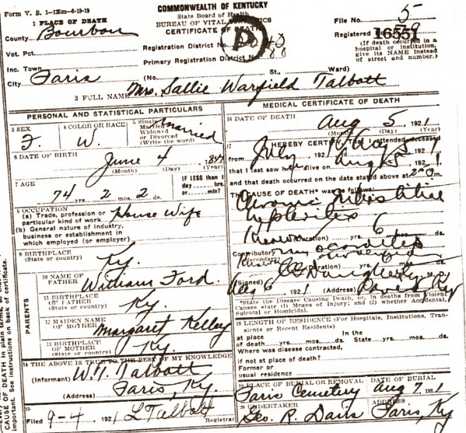
Date: Mon Jan 15 03:47:46 2007
Email: hatton2020@gmail.com
Submitter: Mary Hatton
Death Volume: 1921
Certificate Number: 16551
Surname: TALBOTT
Given Name: Mrs. Sallie Warfield
Date of Death: 05 Aug 1921
Place of Death: Paris, Bourbon Co., Ky.
Race or Color: White
Sex: Female
Marital Status: Married
Spouse's Name:
Spouse's Age:
Cause of Death: Chronic Interstitial Nephritis & Myocarditis
Place of Burial: Paris Cemetery, Paris, Bourbon Co., Ky.
Date of Burial: 07 Aug 1921
Residence: Paris, Bourbon Co., Ky.
Occupation: Housewife
Date of Birth: 04 Jun 1847
Age: 74
Birth Place: Ky.
Father's Name: William Ford
Father's Birth Place: Ky.
Mother's Name: Margaret Kelly
Mother's Birth Place: Ky.
Informant: W. T. Talbott, Paris, Bourbon Co., Ky.
Undertaker: Geo. R. Davis, Paris, Ky.
Comments and Corrections:

