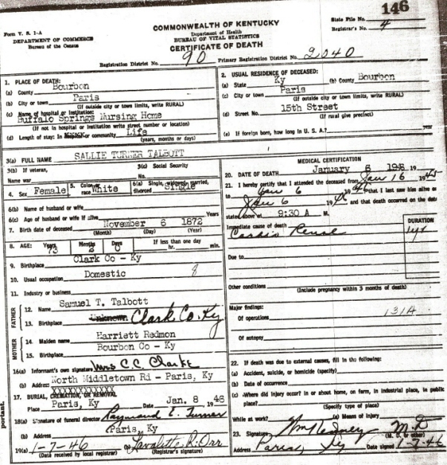
Date: Sat Jan 13 21:40:18 2007
Email: hatton2020@gmail.com
Submitter: Mary Hatton
Death Volume: 1946
Certificate Number: 00146
Surname: TALBOTT
Given Name: Sallie Turner
Date of Death: 06 Jan 1946
Place of Death: Buffalo Springs Nursing Home, Paris, Ky.
Race or Color: White
Sex: Female
Marital Status: Single
Spouse's Name:
Spouse's Age:
Cause of Death: Cardio Renal
Place of Burial: Paris Cemetery, Paris, Ky.
Date of Burial: 08 Jan 1946
Residence: Buffalo Springs Nursing Home, Paris, Ky.
Occupation: Domestic
Date of Birth: 06 Nov 1872
Age: 73
Birth Place: Clark Co., Ky.
Father's Name: Samuel T. Talbott
Father's Birth Place: Clark Co., Ky.
Mother's Name: Harriett Redmon
Mother's Birth Place: Bourbon Co., Ky.
Informant: Mes. C. C. Clark, North Middletown Rd., Paris, Ky.
Undertaker: Raymond E. Turner
Comments and Corrections: The Paris Daily Enterprise-Monday Janurary 7,
1946
Miss Sallie Talbott Dies After 3 Weeks' Illness
Miss Sallie Talbott, 74, died at a local nursing home where she had been
a patient for three weeks. She was born in Clark County and was the
daughter of the late Samuel T. Talbott and Harriett Redmond Talbott.
Miss Talbott was a member of the Paris Christian Church where she was
active in the Women's Missionary Society.
Survivors include a brother, Redmond Talbott, a neice, Mrs. C. C. Clark
Jr. both of Bourbon County, and a nephew, Samuel R. Talbott of
Louisville.
Funeral Services will be held at 2:30 PM Tuesday at the Hinton-Turner
Funeral Home. The Rev. Rhodes Thompson and the Rev. F. M. Tinder will
officiate. Burial will be in the Paris Cemetery.
The body was removed to the funeral home where it will remain for the
service.

