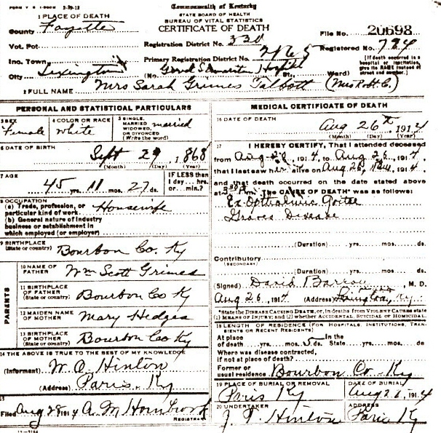
Date: Mon Jan 15 03:39:12 2007
Email: hatton2020@gmail.com
Submitter: Mary Hatton
Death Volume: 1914
Certificate Number: 20698
Surname: TALBOTT
Given Name: Mrs. Sarah Grimes
Date of Death: 26 Aug 1914
Place of Death: Good Samaritan Hospital, Lexington, Ky.
Race or Color: White
Sex: Female
Marital Status: Married
Spouse's Name:
Spouse's Age:
Cause of Death: Ex-Opthalmic Goiter & Graves Disease
Place of Burial: Paris Cemetery, Paris, Bourbon Co., Ky.
Date of Burial: 27 Aug 1914
Residence: Paris, Bourbon Co., Ky.
Occupation: Housewife
Date of Birth: 29 Sep 1868
Age: 45
Birth Place: Bourbon Co., Ky.
Father's Name: Wm. Scott Grimes
Father's Birth Place: Bourbon Co., Ky.
Mother's Name: Mary Hedges
Mother's Birth Place: Bourbon Co., Ky.
Informant: W. O. Hinton, Paris, Ky.
Undertaker: J. T. Hinton

